EC2 scaling: -
- Vertical scaling of ec2 means changing the EC2 instance type from smaller to bigger.
- Horizontal scaling means using more EC2 instances.
**- We have 5 Elastic IP’s maximum for each region and account.
**- Stateful applications must use to Elastic Cache like for app=myclothes.com where the cart details have to be fetched by each instances every time.
This can be done by sticky sessions from ELB to EC2 instances, but the issue with this is when the EC2 goes down the new EC2 is not aware of the last session and the user has to reinitiate the session which will be routed to the new EC2 and the user has to add all the carts shopping details again, so this solution is not the feasible solution.
This can be based on web cookies (Not secured), Server Session id based by Elastic Cache server and when we want to store more data of users like name, address, etc we can use Redis/DynamoDB. so this solution is not the feasible solution.
***Read replicas can be used, which can be maximum 15 read replicas, to make the read queries which makes the write queries faster and high user experience.
**Scaling Reads alternate is Lazy Loading where the EC2 instance asks the Elastic cache if it has the information of this user and if doesn’t have it, then EC2 will query the Databases and will put it back in the Elastic Cache server. So, from next time any query comes the EC2 can get the info from the Elastic Cache server itself.
============================================================================================
****S3 Bucket:-
- Which of the following is NOT a Glacier Flexible retrieval mode? Answer= Instant is not the glacier flexible retrieval mode. Retrieval modes available are :- Expedited(1-5)mins, Standard(3-5)hrs, Bulk(5-12)hrs.
- Which of the following is NOT a Glacier Deep Archive retrieval mode? Answer=Expedited(1-5)mins. Modes available are:- Standard(12)hrs, Bulk(48)hrs.
****Event Notification from S3 can be to SNS (Simple Notification Service), Simple Queue Service, Lambda and Amazon Event Bridge. And we allow resource access policy in these components to allow the S3 bucket access to them.
S3 Performacne:-
Multi Part to upload files parallely.
S3 transfer Acceleration to transfer files faster from 1 region to the another region.
S3 Select to retrieve data only the data required from the S3 bucket.

=============================================================================================
**** IAM: -Admin policy can access all 400 services to AWS but does not have access to the Billing part.
*** Roles are created for the users to assume these roles which have the temporary access (eg- session durations, maximum 1 hrs is allowed by default, Max limit allowed is 1 to 12hrs only), so that will make sure that the users having policy will have permanent access but due to the role assume access it will be temporary. Roles have trust policy where we write the users details, and only those users can assume this role only, not any other person can assume this role.
We can provide cross-account access via Roles, so that any user in different accounts(A) can access the resource in other accounts (B). Here the user is supposed in account (A) then the roles will be made in Account(B) where the role has a Role + S3 access + Session duration + Trust Policy (ARN of the user of account who wants access). To create a role for a user, select the AWS account while creating a role.
*** Policy are permissions to the resources. Users are attached to the policies. User groups can be created to avoid operational overhead, where we can attach policies to the user groups and the users access can be managed efficiently.
*** There are 2 types of roles:- (1) User role- Like assuming the roles, (2) Service Role(Any AWS resources trying to perform actions to other services.
** Organisation Unit> Account(Management Account> (1) It has the sub accounts where we can have the consolidated Bills and discounts. (2) It has SCP (Service control policy) allows to decide the max permission a user can have may it be root or any other user.
** VPC:- VPC is resgional level and In VPC we can use upto 5 CIDR and the min and max subnets allowed are from 16 to 28 only.
** AWS VPC reserves 5 IP’s per subnet,not per VPC. So every Subnet created under a VPC, AWS reserved 5 IP’s. AWS doesn’t support broadcasting IP’s.(Ip reserved are .0, .1,.2 .3, and .255
***IGW is Internet gateway region level and purpose is to connect the internet to the VPC.
*** 1 VPC will have 1 Internet Gateway.
*** Route tables help the network to guide the traffic. We create Route tables for each subnet within each AZs. With Route tables entry only, internet access to the app or to the local access within servers is possible.
*** Nat-Gateway (Network Address Translation) is used when the private server in a private subnet needs to be communicated to internet for some updates/patches etc. This is only valid for the outbound session from the server side only. No external connection is possible through this NAT Gateway. The NAT gateway is created in the public subnet of the same VPC and hence the private server of the private subnet can make requests to the local network till public subnet. Then we create NAT rule in the private server which is in the private subnet
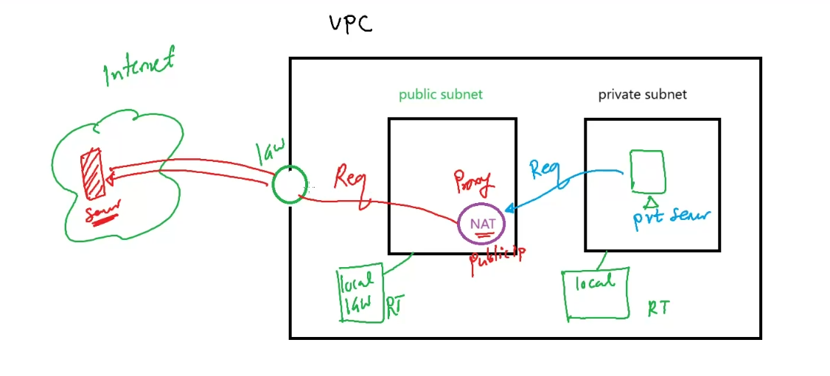
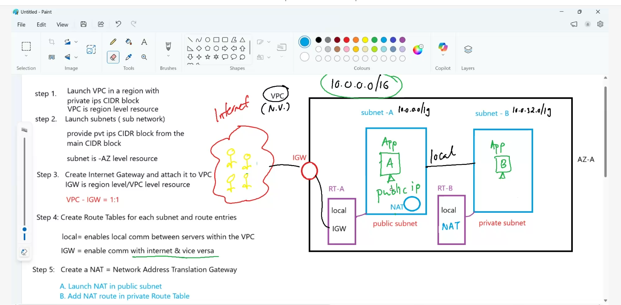
**RDS**
** RDS is not a serverless service although it is PAAS service where OS is taken care of by the AWS and hence the user cannot make SSH and a user cannot install the database application. Users just give from its choice which Database engine they want like: - Postgress SQL, MariaDB< MSSQL, IBMDB2, Oracle, MySQL, and the AWS deploy the respective database engine for us. RDS is AZ level service, but it can be added to the Multi AZ.
***ASG** is a regional service that means ASG can be extended to the AZ’s in a single region only.
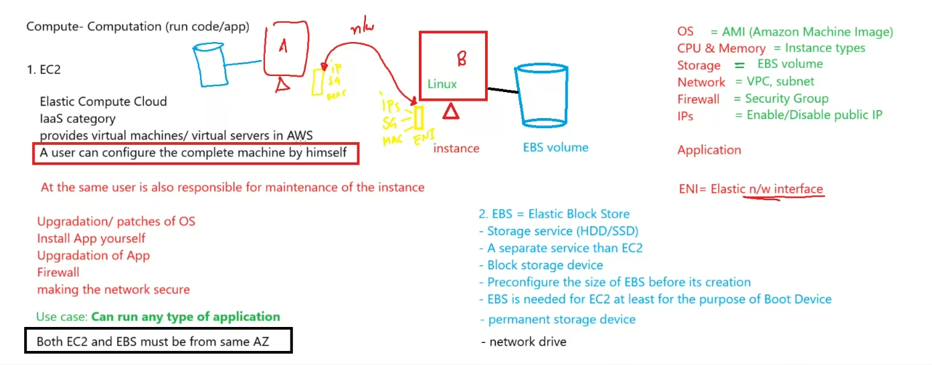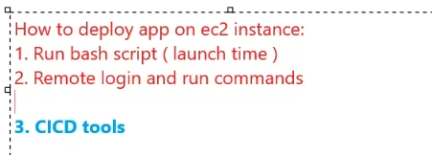
**EBS Types
https://docs.aws.amazon.com/ebs/latest/userguide/ebs-volume-types.html
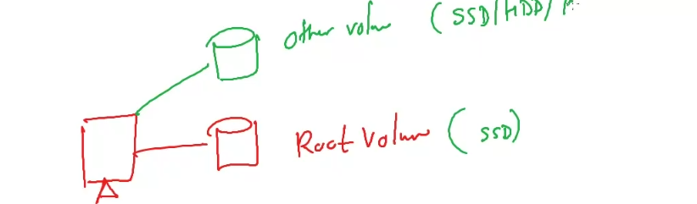
EBS and AZ should be from same AZ.
***EC2 purchase plan: -
https://docs.aws.amazon.com/AWSEC2/latest/UserGuide/instance-purchasing-options.html
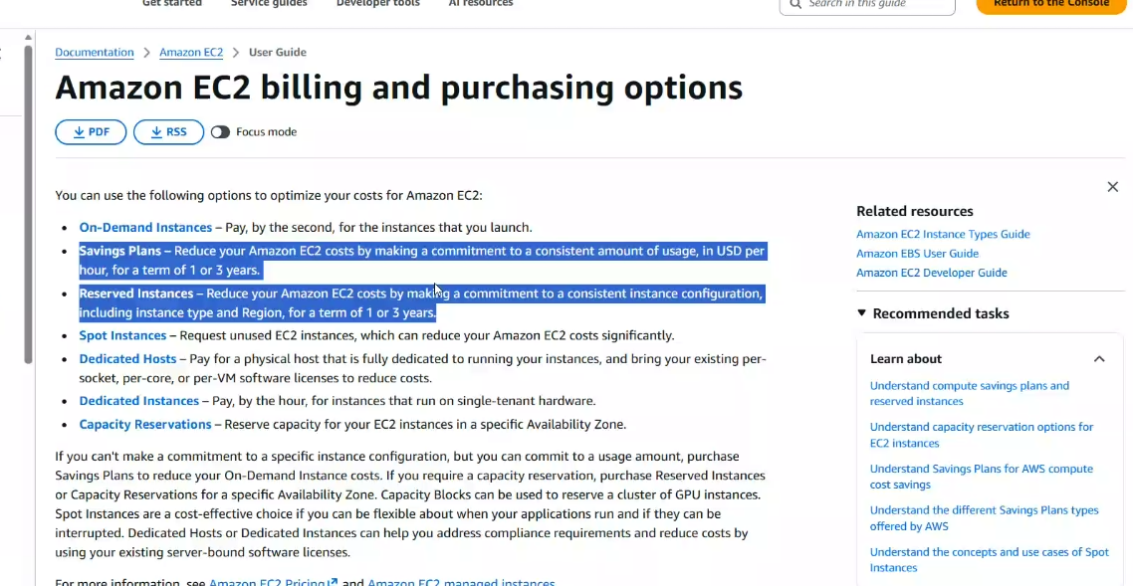
Difference in Savings plan and the reserved instance: - In savings plan also we get up to 70% discounts but we can the instance types but in case of the reserved instances we can’t change the plan eg:- Region, AZ, Instance type..
Spot instances are the ones which give most discounts up to 90%. But the availability is very low.

** ***ECS- Elastic Container Service uses Fargate & EC2 are the instances are used by ECS. Fargate is serverless and Ec2 is always not serverless service.
**** VPC Endpoint: - VPC endpoints also called interface endpoint, enables your resources inside the VPC to connect the AWS services like DynamoDB, S3, SQS, SNS etc via the internal AWS network. Via the VPC endpoint the traffic will not traverse through the internet. Route tables are not required for configuration. These are also Elastic network Interfaces which are within VPC.
** Gateway Endpoint: - Gateway endpoint is only used for S3. Route table configurations are required for the Gateway endpoint.
***VPC Peering:- Connect 2 different VPC’s. Can be in 2 different regions, accounts as well. Its free of charge.
***Tranisit Gateway**-- Where more than 2 VPC’s needs to be connected. This is a charged service.
***AWS Site-to-site VPN:- Connecty on premise to AWS VPC. Advanatge:- 1. Quick Setup, 2. Less costly. 3. Public interet access. 4. Encryption is IPSEc.
Disadvantage:- Limited Bandwith 1.23 GBPS.
***AWS Direct Connect:- 1. Dedicated private connection (No public internet), 2. It is faster, 3. it supports IPSEC, 4. it is very costly, 5. Time to set up canbe up to 3 months..6. Speed is from 100 GBPS to 600GBPS.
***SQS:- Simple Queue service:- Push Message API from Producer, Poll to get the messages at the consumer end. Long Poll is to wait for the messages once they arrive in SQS. That mesns Long Polling decreases the number of API calls made to SQS while increasing the efficiency and reducing the latency of your application. Long polling is preferred than Short polling, it can be nebaled at the queue level or at the Api level using Wait time seconds.
SQS is used to decouple the applications, SQS can also be used to write requests in Databases via Enque and Deque configurations which ensures the data is not lost to be written in the database even the database is experiencing heavy loads at their end.
***Kenisis** is a real time message streaming service.
*** Amazon Data Firehose**:- It is a near real time and It is a way to load the streaming data streaming service which can give data to S3, redshift(for data anlalytics), splunk etc.. or to any http endpoint in the world, It was also called delivery streams before in Aws terms.
*** LAMBDA:- Serverless feature of AWS which is used to run code without worrying about the underlying servers. It can be triggered by an event-based mechanism and can run code of your choice. Sample code of Lambda:-
List AWS Functions
aws lambda list-functions
Invoke Lambda Function SYNCHRONOUSLY
aws lambda invoke --function-name functionx --payload '{"key1": "value1", "key2": "value2", "key3": "value3" }' response.txt
cat response.txt
Asynchronous Invocation
aws lambda invoke --function-name functionx --payload '{"key1": "value1", "key2": "value2", "key3": "value3" }' --invocation-type Event response.txt
cat response.txt
Update:
aws lambda update-function-configuration --function-name functionx --environment Variables="{ENVIRONMENT_NAME = Sameer}"

Create a Lambda Function - Through CMD
aws lambda create-function --function-name My_Demo_Lambda_Function --handler lambda_function.lambda_handler --runtime python3.9 --role arn:aws:iam::374152831498:role/LambdatoDynamoDB --zip-file fileb://lambda_function.zip --region us-east-1

Important Links for exam prep:-
Documentation Website
https://docs.aws.amazon.com/
Skillbuilder
https://skillbuilder.aws/category/domain/database
Examp prep:
https://aws.amazon.com/certification/certified-solutions-architect-associate/
Exam guide:
https://d1.awsstatic.com/onedam/marketing-channels/website/aws/en_US/certification/approved/pdfs/do…
Exam pre material on Skill Builder
https://skillbuilder.aws/learn
Examptopics.com dump of questions
https://www.examtopics.com/exams/amazon/aws-certified-solutions-architect-associate-saa-c03/
Udemy exam prep courses
Serverless Computing – Amazon Web Services
Solution Labs for different solutions in different clients. AWS Solutions Library | Amazon Web Services | AWS
Back up and DR link:- https://aws.amazon.com/blogs/architecture/disaster-recovery-dr-architecture-on-aws-part-i-strategies-for-recovery-in-the-cloud/
Database Migration :- https://docs.aws.amazon.com/prescriptive-guidance/latest/migration-database-rehost-tools/dms.html
Data Transfer Service - AWS DataSync - AWS
AWS Storage Gateway | Amazon Web Services
AWS Snowball | Secure Edge Computing and Offline Data Transfer | Amazon Web Services

Application Migration :- https://aws.amazon.com/application-migration-service/

** Amazon Rekognition:- For image and video recognition.
**Amazon Transcribe:- To Convert Speech to text. It uses deep learning process called Automatic Speech Reconginition (ASR ) to convert speech to text. It automatically removes the PII. Support automatic language identification for multi lingual audio.
Use Case:- 1. Transcribe customer service calls. 2. Automated closed captioning and subtitling. 3. Generate metadata for media assets to create fully searchable archive.
** Amazon Polly:- Turn Tex to life like Speech using deep learning. For Stylish words, acronyms or pronounciations of words we use Pronounciations lexicons and for more customisation like whispering, pheontics use SSML (Speech Synthesis Markup Language). Amazon Polly allows you to turn text into speech. It has two important features. First is Pronounciation Lexicons which allows you to customize the pronunciation of words (e.g., “Amazon EC2” will be “Amazon Elastic Compute Cloud”). The second is SSML(Speech Synthesis Markup Language) which allows you to emphasize words, including breathing sounds, whispering, and more
**Amazon Translate**- Translate text from 1 language to another
**Amazon Alex**: It is for ASR(Automatic Speech Recongition).
**Amazon Connect**:- It is for call centre or customer centre.
**Amazon Comprehend**:- Used for NLP(Natural Language Processing). It can find the Language of the text, understand the sentiments of the (+tive or -tive). It means it can be used to find the meaning in the text and the sentiments.
Use Case:- 1. Customer emails (+tive, -tive). 2. Create and group articels by topics.
**Amazon Sagemaker**:- It is AWS service to build the machine learning model.
**Amazon Kendra**:- Amazon service used to for the document search, it can search answers for the document.
***Amazon Personalise**:- This AWS ML service is used to make individualised recommendations for the customers using any applications.

